Saeed Mahmood
Senior Planner
Buckinghamshire Council
King George V House,
King George V Rd,
Amersham
Bucks, HP6 5AW
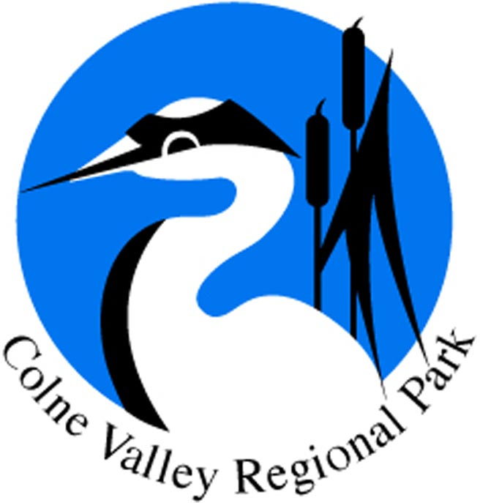
October 2020

Dear Saeed

Re: PL/20/2537/HS2

The Colne Valley Park exists to maintain and enhance the Colne Valley as the first taste of countryside to the west of London for the benefit of more than three million people who live within 10 miles of the Park. The Park covers an area from Rickmansworth to Staines, across parts of Herts, London, Bucks, Berks and Surrey. The six objectives of the Park are:
- To maintain and enhance the landscape, historic environment and waterscape of the Park in terms of their scenic and conservation value and their overall amenity.
- To safeguard the countryside of the Park from inappropriate development. Where development is permissible it will encourage the highest possible standards of design.
- To conserve and enhance biodiversity within the Park through the protection and management of its species, habitats and geological features
- To provide opportunities for countryside recreation and ensure that facilities are accessible to all.
- To achieve a vibrant and sustainable rural economy, including farming and forestry, underpinning the value of the countryside.
- To encourage community participation including volunteering and environmental education. To promote the health and social well-being benefits that access to high quality green space brings.

The Colne Valley Park and HS2
The Colne Valley Park is publicly and determinedly opposed to the HS2 project, which will have a direct, negative and permanent impact on a precious and already vulnerable landscape. The railway hits the Colne Valley particularly hard – the project includes two tunnel portals, an enormous viaduct and many construction sites.

We lobbied against HS2 and were deeply dismayed when it was granted permission by the government through the Hybrid Bill and following the 2019 review.

HS2’s work has become increasingly visible during the course of the last year. Many familiar and popular views across the Colne Valley are being compromised, woodland felled, paths closed, and the effects of traffic disruption felt. Therefore measures to lessen impact must be taken at every opportunity.

This application

If a bridge has to be built in Denham Country Park then my understanding from Bucks Country Parks is that this is possibly the ‘least worst’ locations for it as any alteration of the bridge location will, because of large vehicle turning circles etc, result in increased environmental damage to trees etc because of consequent re-siting of access tracks.

I make the following points:
A)impact on the river to be considered and need for ecological & environmental impact assessment
B)the bridge is right on top of a ‘constant effort’ riverfly monitoring site, see https://www.cvfc.org.uk/ and https://rflies.uk/public.html . Compensation should be made to Colne Valley Fisheries Consultative through a financial contribution to their monitoring efforts throughout the Colne Catchment.

Regards

Stewart Pomeroy
Managing Agent

For and on behalf of the Colne Valley Park Community Interest Company

cc Cllr Warren Whyte Cabinet Member
Ian Thompson Corporate Director, Planning and Sustainable Growth

