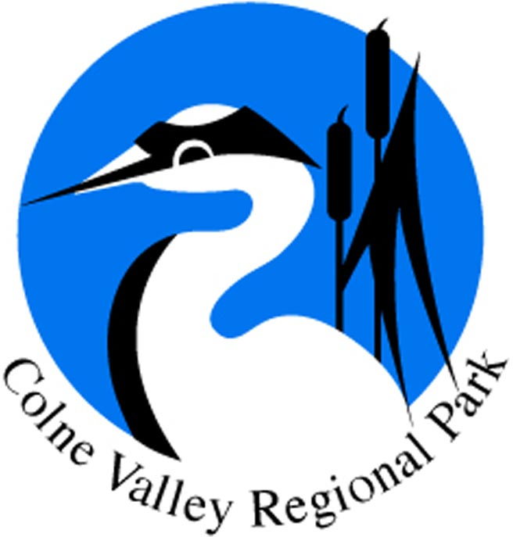

Dear Sir/Madam

Re: Lea PL/19/4159/FA

The Colne Valley Park CIC exists to maintain and enhance the Colne Valley as the first taste of countryside to the west of London for the benefit of more than three million people who live within 10 miles of the Park. The Park covers an area from Rickmansworth to Staines, across parts of Herts, London, Bucks, Berks and Surrey. The six objectives of the Park are:
- To maintain and enhance the landscape, historic environment and waterscape of the Park in terms of their scenic and conservation value and their overall amenity.
- To safeguard the countryside of the Park from inappropriate development. Where development is permissible it will encourage the highest possible standards of design.
- To conserve and enhance biodiversity within the Park through the protection and management of its species, habitats and geological features
- To provide opportunities for countryside recreation and ensure that facilities are accessible to all.
- To achieve a vibrant and sustainable rural economy, including farming and forestry, underpinning the value of the countryside.
- To encourage community participation including volunteering and environmental education. To promote the health and social well-being benefits that access to high quality green space brings.

The Colne Valley Park CIC objects to this application to create a 500-seat crematorium, dining hall with 157 car and 6 coach parking spaces and upgraded & widened access road in the green belt. This objection is because:
- The development is contrary to Green Belt Policy, will harm the Colne Valley Regional Park and the 'Very Special Circumstances' for development in the green belt are not met
- There is a lack of detail
- Mitigation is inadequate
- The site is in flood zone 2
More detail on points A to C is given below.

A. Very Special Circumstances for development in the green belt are not met. The bullet points given in section 5.3.9 of the Green Belt Assessment are inadequate justification and some, such as “funds in place to ensure delivery”, are simply irrelevant.
- Assessment of contribution of the site to Green Belt purposes is inaccurate and fails to pick up on the role of this site in this green wedge between the Greater London conurbation/Ickenham/Uxbridge and Denham
- this is a fragile, narrow, green gap and the openness of the site is important to the integrity of the Green Belt
- the site is surrounded by open land and not "existing development" as spuriously suggested in para 8.1.2 of the Green Belt assessment: "The Site does not contribute to the first four NPPF Green Belt purposes due to the extent of existing development already surrounding the Site."
- Presence of buildings on the site does not reduce its importance in Green Belt terms and emphasises the value of retaining what openness remains
- The site is an important part of the valley floor landscape. As referenced to in the South Bucks Landscape Character Assessment, 2011 ‘Colne Valley Floodplain’ and Colne Valley Park Landscape Character Assessment 2018 ‘Colne Valley: Rickmansworth to Uxbridge’.
- The proposal involves significant built form and creeping urbanisation in a sensitive green gap/ valley floor
- In view of the conflict with Green Belt policy the investigation into alternative sites is inadequate. The development would serve a very large catchment which leads to a very wide area of search
- There is no convenient public transport to the site and the proposal would involve a large number of car trips contributing to the intrusion and poor sustainability credentials. We don’t believe that the claims about taxis and coaches would address this issue.
- We dispute the claim that the loss of open-ness of the greenbelt is only internal to the site. Open-ness has to be judged based on the specific circumstances. The development is a permanent change to the site and locality. Trees and vegetation are temporary and also change with the seasons. The site occupies a position in the heart of this green gap and in the heart of the river valley where openness is a key ingredient to character of the Green Belt and Colne Valley Regional Park. The openness of the site itself is an important consideration and relevant to the application of GB policy, not just what may or may not be seen from more distant views - this is a long-established principle in the Green Belt
This is the wrong site for such a large development and the impact would set a very unfortunate precedent

B. There is a lack of detail. For example, the ecological assessment is insufficient for a development of this size. No species surveys appear to have been undertaken, the ‘Preliminary Ecological Appraisal Survey’ only refers to a desk study, a phase 1 habitat survey and a preliminary bat roost assessment. We could not find any specific reference to how the limited biodiversity and access improvements proposed will be maintained in the future.

C. The mitigation is inadequate for a development of this size in the green belt. The ‘technical note: Biodiversity Metric’ describes the habitat on site as in ‘sub optimal (poor)’ condition and gives a score of 43.97 biodiversity units. This low value is because the current site management regime of mowing grassland vegetation is detrimental to biodiversity. This low baseline results in very little intervention to give the required biodiversity gain of 6.9%. Woodland/hedgerow management, a small amount of tree planting and ditch enhancements is, in our view, completely inadequate to mitigate for a development of this size in the green belt.

The development does not make a positive contribution to the Colne Valley Regional Park’s six objective (listed above). Opportunities for improved mitigation are not being taken. For example:
- There should be significantly more biodiversity enhancement both on site and off site in the adjacent Denham Country Park.
- The previous planning application from the Anoopam mission (ref:1700090FUL) to create an access point to Denham Court Drive has resulted in a significant increase in flytipping due to poor design. This current planning application should take the opportunity to improve the design layout of the junction with Denham Court drive to ‘design out’ this recently created problem.
- The proposed path and bridge to Denham Country Park should a) have a clear commitment that this will be freely open to and accessible for the public and b) be designed to link in with, complement and enhance the existing rights of way network in the Colne Valley Regional Park. This could be achieved through links to the proposed Lea Quarry paths to the west and across the Colne to the Grand Union Canal to the east. We are disappointed that the Anoopam mission and their neighbouring landowners on both sides (Boyer Leisure) are working in silos which is resulting in failure to take these opportunities which could strengthen any future planning applications.

Regards

Stewart Pomeroy
Managing Agent

For and on behalf of the Colne Valley Park Community Interest Company

