London Borough of Hillingdon
South Bucks District Council

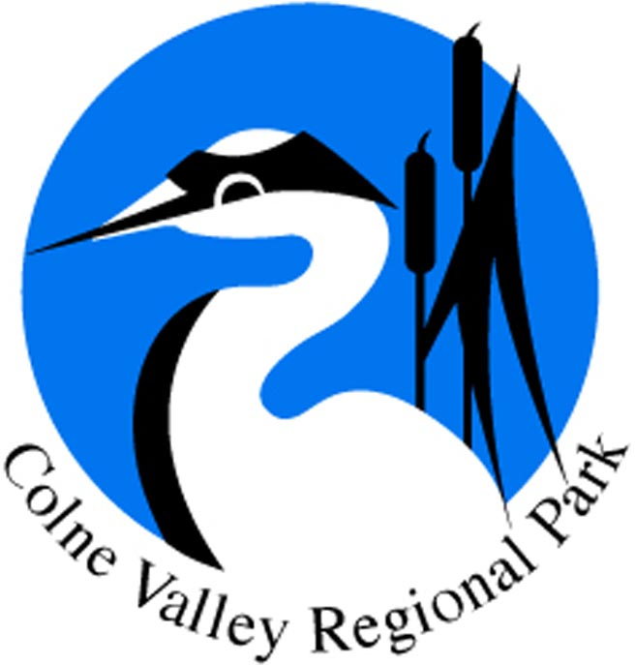
October 2019

Dear Sir/Madam

Re: Colne Valley Viaduct
South Bucks District Council - PL/19/3332/HS2 - High Speed Rail (London - West Midlands) Act 2017 – Approval of details.
London Borough of Hillingdon – Reference 74320/APP/2019/3187

The Colne Valley Park CIC exists to maintain and enhance the Colne Valley as the first taste of countryside to the west of London for the benefit of more than three million people who live within 10 miles of the Park. The Park covers an area from Rickmansworth to Staines, across parts of Herts, London, Bucks, Berks and Surrey. The six objectives of the Park are:

- To maintain and enhance the landscape, historic environment and waterscape of the Park in terms of their scenic and conservation value and their overall amenity.
- To safeguard the countryside of the Park from inappropriate development. Where development is permissible it will encourage the highest possible standards of design.
- To conserve and enhance biodiversity within the Park through the protection and management of its species, habitats and geological features
- To provide opportunities for countryside recreation and ensure that facilities are accessible to all.
- To achieve a vibrant and sustainable rural economy, including farming and forestry, underpinning the value of the countryside.
- To encourage community participation including volunteering and environmental education. To promote the health and social well-being benefits that access to high quality green space brings.

The Colne Valley Park Community Interest Company (CIC) wishes to register its grave concern about the proposal for the HS2 Colne Valley Viaduct, which is the subject of the recent Schedule 17 application to your authority.

The Colne Valley Park and HS2
The Colne Valley Park Community Interest Company (CIC) is publicly and determinedly opposed to the HS2 project, which will have a direct, negative and permanent impact on a precious and already vulnerable landscape.
We lobbied against HS2 and were deeply dismayed when it was granted permission by the government. We hope it may yet be halted following the review that is currently under way, but in the meantime we must continue to assume it is going ahead.
Its impact on the countryside is already being felt as preparatory work is carried out along the route between London and Birmingham. The railway hits the Colne Valley from Ickenham to Chalfont St Peter particularly hard – the project includes two tunnel portals, an enormous viaduct and many construction sites. We would have preferred a tunnel to take the line beneath the Colne Valley, but the government rejected that call.
While the prospect remains that the HS2 railway could be built, we continue to press for mitigating measures that will lessen its impact wherever possible.
HS2’s preparatory work has become increasingly visible during the course of the last year or so. Many familiar and popular views across the Colne Valley are beginning to be compromised, woodland felled, public footpaths closed, and the effects of traffic disruption felt.
Mitigation for the environmental impact of the viaduct
The viaduct design as submitted fails to address the need for full mitigation of its impact on the landscape of the Park. We wish to see firm proposals secured that protect existing routes and provide certainty that high quality alternative and compensatory routes will be provided. Where routes are affected, we urge the local authorities to require that specific detailed mitigation is presented, and this must include clearly set out alternative routes to be provided, the specific timing for the provision of these routes, and details of their design (landscape provision, their widths, forms of enclosure, surfacing etc.).
We are extremely concerned at the continued loss of trees and woodland along the route within the Regional Park and the impact these losses are having on the its landscape and wildlife. We urge local planning authorities to use the powers available to them to take proactive measures to protect trees affected by this major project, and ensure felling only applies to those trees whose removal is genuinely essential to the project, and that those that can be retained are afforded legal protection. This will significantly reduce the risk of additional trees being lost needlessly during the construction and operational phases of the project.
We have grave concerns about the impact this huge viaduct will have on those areas it will cross, and the environment beneath and around it. These areas will need to be properly managed and maintained to the highest standards. We fear that poor design and lack of certainty about adequate future maintenance will merely repeat the problems we are currently actively working to address at the A40 viaduct: a heavily graffitied, litter-strewn and oppressive environment, which people understandably prefer not to enter. This flies in the face of spirit and demands of our six stated objectives. We ask that the local planning authorities ensure any approval they grant will include specific and detailed obligations in respect of the management and maintenance of all public realm associated with the viaduct. It is the only way in which the HS2 project can be held properly to account, and the impact on the Park minimised.
Yours sincerely

Stewart Pomeroy
Managing Agent

For and on behalf of the Colne Valley Park Community Interest Company

