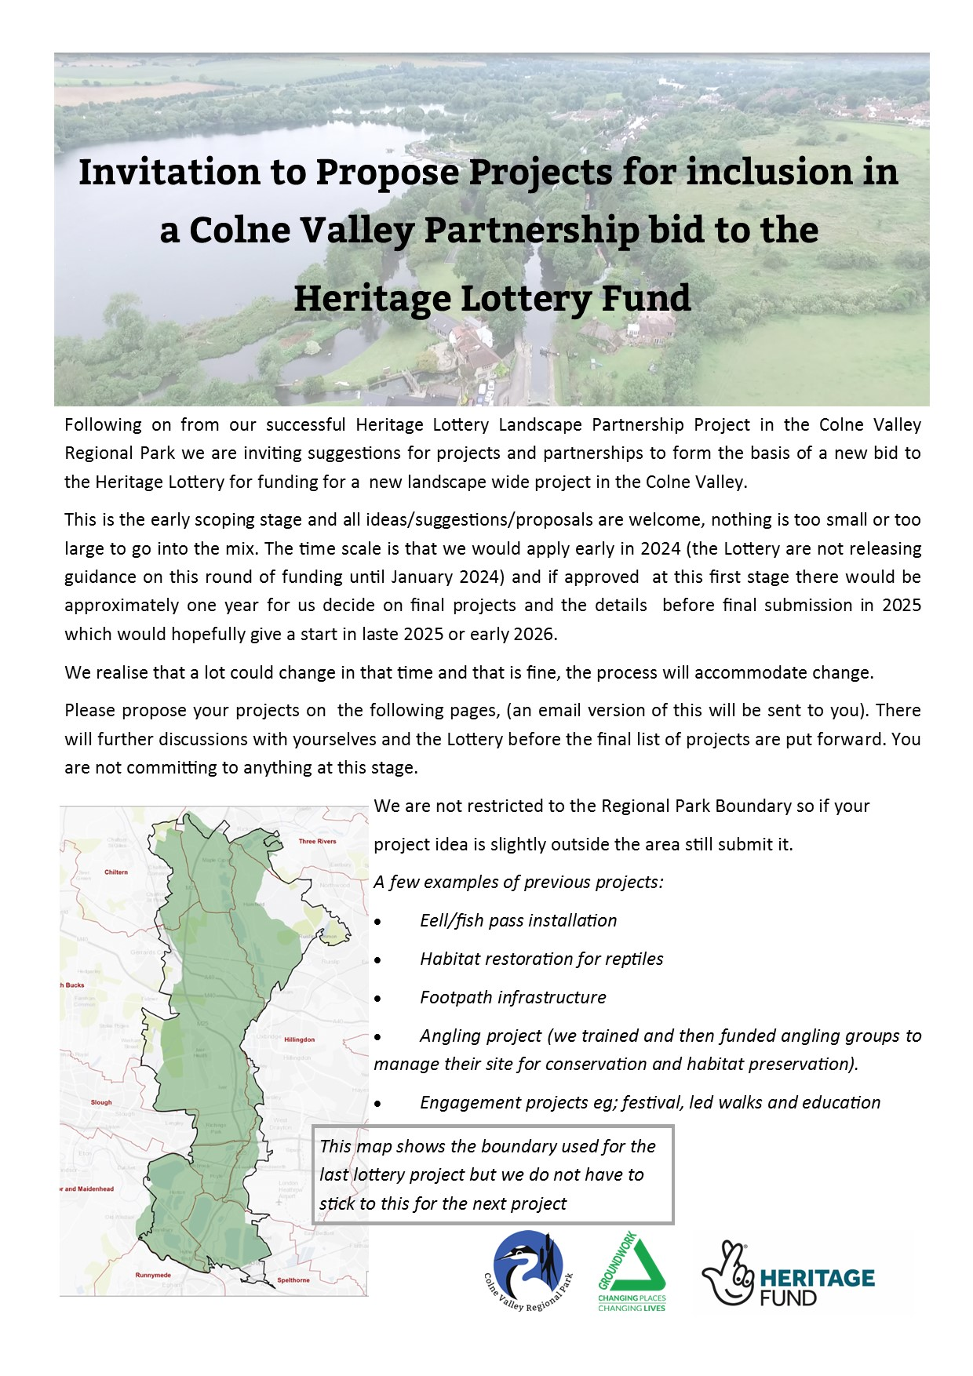
We would welcome your suggestions for projects that we can include in a partnership bid to the Heritage Lottery.
- No project is too large or too small to include.
- At this stage we only need outline details – if you cannot fill in all the boxes that is fine.
- Projects can be site based ie habitat restoration, across the landscape ie several projects along a river or engagement focused ie an education programme, led walks or information boards.
- We will be linking projects together to make a landscape scale strategy, so all ideas are welcome.
Organisation
Contact name
Contact email
Project name
Brief description

Location
Size of site if applicable
Desired outcomes

Costings:
Obviously difficult to cost at this point but an indication of the size of the project and the split between capital/contractor costs and staff costs would be very helpful. We will not hold you to this!

Project cost estimates, just ballpark figures at this point: gross figures please
Staff time
Contractors
Materials
Total cost Gross

PTO
Set up:
Potentially projects can be proposed as:
- actioned by GWS staff with landowner permission.
- organisations with larger projects can be full partners and have their own project staff to deliver their own projects.
- Organisations can apply for funds from the project to deliver individual improvements themselves.
We do not have to decide how a project will be set up at this stage.

Feel free to add any other information, maps or photos or attach files.

If you would like further information, please contact Deborah.Valman@groundwork.org.uk.
We would like to keep you updated on this project from time to time, please tick if you would like to opt out of these emails.
Thank you for your time.

